How to access Past Sessions in DIA Virtual Conferences:
Log in to the DIAGlobal.org website.
Go to the “My Account” button in the drop down menu in the top right hand corner
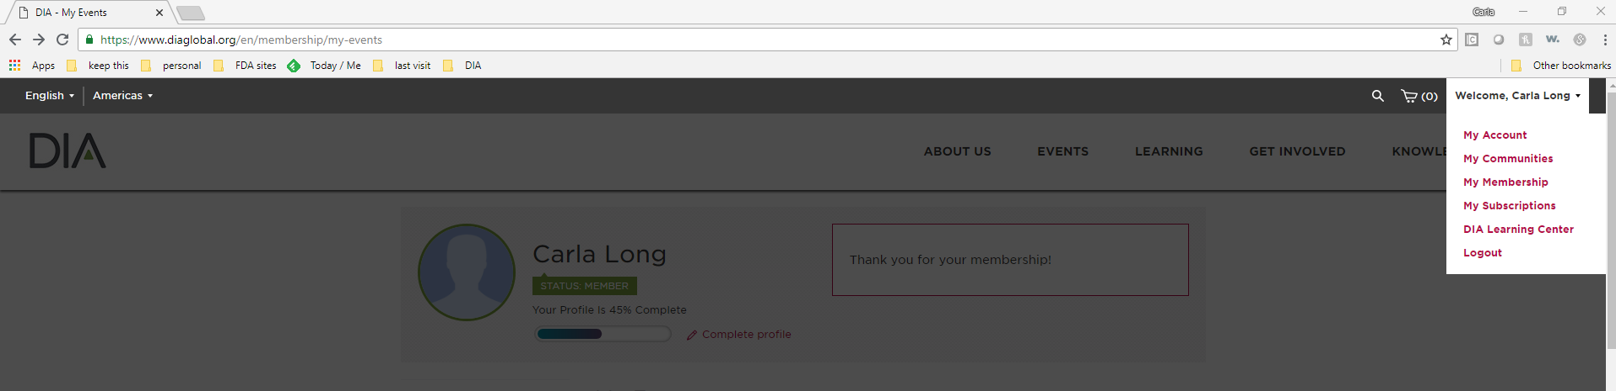
Under the desired conference, Click on “Review Presentations”
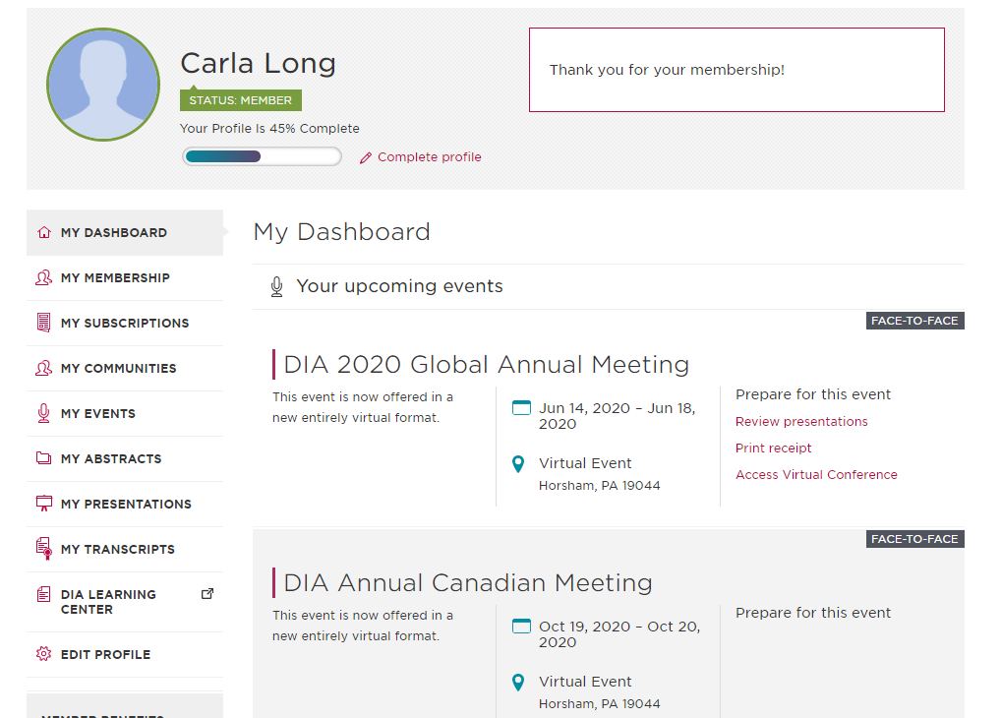

In My Presentations, click on the desired Conference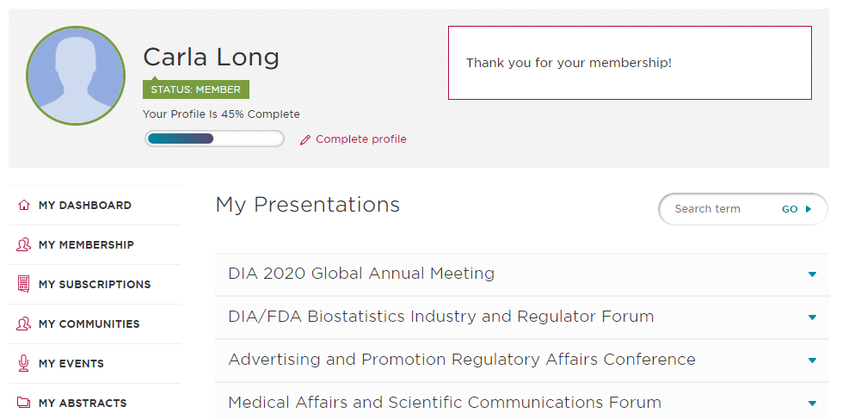
This will open and show all available presentations from the Conference
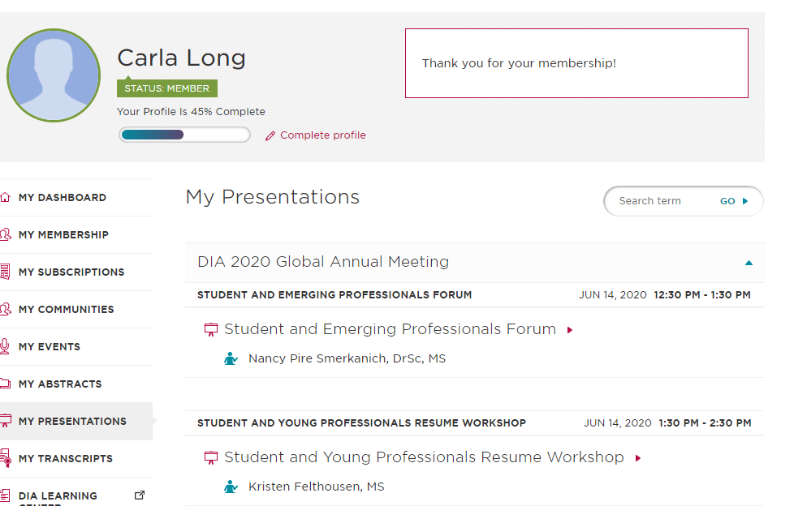
Click on the title of the session you would like to view, this will bring you to the slide deck.
Enjoy!

