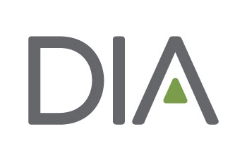
Half Day and Full Day Short Course Abstract Form

Use this form to prepare your short course abstract prior to visiting the DIA website. This will help ensure that you have all of your required information available when you submit your abstract. All abstracts must be submitted online by the designated deadline.

Should you have questions regarding the abstract submission process, please contact annualmeetingprogram@DIAglobal.org

Total number of instructors including authors:

Track (Select one): Choose from the list of interest areas and select only one track that best fits your abstract. Refer to the call for abstracts announcement for a list of tracks.

Level of Difficulty (Select one):
O Basic: Appropriate for individuals new to the topic/subject area.
O Intermediate: Appropriate for individuals who already have a basic understanding of the topic/subject
area.
O Advanced: Appropriate for individuals with an in-depth knowledge of the topic/subject area.

Learning Objectives (400 character limit, including spaces): Please provide 2-3 learning objectives that clearly explain what participants should be able to do after attending this event. Click here for a list of suggested verbs to create these objectives.

Insert details here
Target Audience (450 character limit, including spaces): This short course is designed for:

Insert details here

Short Course Overview (2000 character limit, including spaces): Please provide an Overview description describing the short course. This overview will be used to review the abstract as well as used to publicize the short course should it be accepted as an educational offering in a DIA event.
Note: Half Day Short Course consists of 3 hours and 15 minutes of instruction and Full Day Short Course provides 6 hours and 30 minutes of instruction time
Insert details here

